**2nd Lt David Crow**

**ENG/20M**

**CSCE 560 Homework 5**

**Chapter 6 – Link Layer**

**Fall 18**

**Assigned: Monday, 19 Nov**

**Due: Monday, 3 Dec, 1400**

**Problem 1**. Chapter 6, R4

Suppose two nodes start to transmit at the same time a packet of length L over a broadcast channel of rate R. Denote the propagation delay between the two nodes as dprop. Will there be a collision detected if dprop < L/R? Why or why not?

Because it takes longer to transmit the packets onto the link than it takes each packet’s bits to cross the link, and because the nodes are transmitting onto a broadcast channel, the nodes will detect a collision while they are transmitting.

**Problem 2**. Chapter 6, R6  
In CSMA/CD, after the fifth collision, what is the probability that a node chooses K = 4? The result K = 4 corresponds to a delay of how many seconds on a 10 Mbps Ethernet?

CSMA/CD chooses at random from an interval of . Here, that interval is , and, because all values are equally likely, .

If the node chooses , the node will wait .

**Problem 3**. Chapter 6, R11  
Why is an ARP query sent within a broadcast frame? Why is an ARP response sent within a frame with a specific destination MAC address?

According to the textbook, the purpose of ARP queries is “to query all the other hosts and routers on the subnet to determine the MAC address corresponding to the IP address that is being resolved.” Thus, because the querying node doesn’t know the physical address corresponding to the IP address being resolved, ARP queries are sent within broadcast frames to ensure the query reaches all nodes in the subnet.

Because the responding node knows the IP and physical addresses of the querying node, it sends the ARP response directly to the querying node; there’s no reason to broadcast information that the other nodes don’t need.

**Problem 4**. Chapter 6, R12  
For the network in Figure 6.19, the router has two ARP modules, each with its own ARP table. Is it possible that the same MAC address appears in both tables? Why or why not?

No, it is not possible. Each ARP table corresponds to a distinct Local Area Network, and each adapter in the LAN has a unique physical address.

**Problem 5**. Chapter 6, P5  
Consider the 5-bit generator, G=10011, and suppose that *D* has the value 1010101010. What is the value of *R*? You must show your derivation of *R*.

First, note that , so . We now divide by and let be the remainder (here, is the concatenation of and 0s).

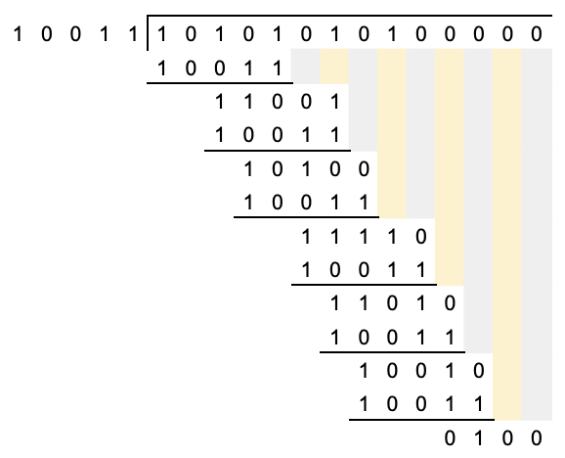

Thus, .

**Problem 6**. Chapter 6, P8  
In Section 6.3, we provided an outline of the derivation of the efficiency of slotted ALOHA. In this problem we'll complete the derivation.

1. Recall that when there are N active nodes the efficiency of slotted ALOHA is Np(1-p)N-1. Mathematically derive the value of p that maximizes this expression.

The efficiency is at a maximum when the tangent of the efficiency curve is horizontal. That is, the efficiency is at a maximum when the derivative of the curve is equal to zero.

If , then

.

We can see that there are two possible solutions: and . We can rule out because clearly ; we thus know that will maximize the efficiency.

1. Using the value of p found in part (a), find the efficiency of slotted ALOHA by letting N approach infinity. Hint: (1 - 1/N)N approaches 1/e as N approaches infinity.

We’ll plug into . Thus, .

This is equivalent to . It’s clear the denominator approaches , and we’re told that the numerator approaches , so we know that approaches .

**Problem 7**. Chapter 6, P18  
Suppose nodes A and B are on the same 10 Mbps Ethernet bus, and the propagation delay between the two nodes is 325 bit times. Suppose CSMA/CD and Ethernet packets are used for this broadcast channel. Suppose node A begins transmitting a frame and, before it finishes, node B begins transmitting a frame. Can A finish transmitting before it detects that B has transmitted? Why or why not? If the answer is yes, then A incorrectly believes that its frame was successfully transmitted without a collision. *Hint:* Suppose at time t = 0 bit times, A begins transmitting a frame. In the worst case, A transmits a minimum size frame of 512+64 bit times. (The additional 64 bits are for the preamble and the start frame delimiter.) So A would finish transmitting the frame at t = 512+64 bit times. Thus the answer is no, if B's signal reaches A before bit time t = 512+64 bits. In the worst case, when does B's signal reach A?

We know that A finishes transmitting at bit times. Because it takes bit times for the bits to propagate across the link, we know that any bits transmitted at B after time bit times cannot propagate to A before A finishes transmitting. In other words, A will finish transmitting without detecting a collision if B starts transmitting after time bit times.

Conversely, if B starts transmitting at time bit times (or earlier), its bits will begin arriving at node A at time bit times (at the latest), and thus A will detect a collision and pause its transmission.

**Problem 8**. Supplemental Problem 1  
Suppose two nodes, A and B, are attached to opposite ends of an 800 m cable, and that they each have one frame of 1500 bits (including all headers and preambles) to send to each other. Both nodes attempt to transmit at time t=0. Suppose there are four repeaters between A and B, each inserting a 20-bit delay. Assume the transmission rate is 10 Mbps, and CSMA/CD with backoff intervals of multiples of 512 bits is used. After the first collision, A draws K = 0 and B draws K = 1 in the exponential backoff protocol. Ignore the jam signal and the 96-bit time interframe delay.

1. What is the one-way propagation delay (including repeater delays) between A and B in seconds? Assume that the signal propagation speed is 2x108 m/sec.

The total one-way is equal to the propagation delay over the link plus the transmission delays for each repeater. Thus, .

1. At what time (in seconds) is A's packet completely delivered at B?

At time , both A and B detect a collision. It takes another for the rest of the bits to pass by A and B (for the link to become idle). Thus, the link is idle at time . B drew , so it must wait . Because the propagation delay is significantly less than this, we know A’s bits will reach B before B attempts retransmission. In other words, we don’t need to worry about collisions anymore.

Let’s resume the calculation. At time , A detects an idle link and begins transmitting. We know . Thus, A’s packet is completely delivered at time s.

1. Now suppose that only A has a packet to send and that the repeaters are replaced with switches. Suppose that each switch has a 20-bit processing delay in addition to a store-and-forward delay. At what time in seconds is A's packet delivered at B?

The host/each switch requires to transmit the packet. We already found the sum of the propagation and processing delays in part (a), so we can sum over all delays.

Thus, at time , A’s packet is completely delivered at B.

**Problem 9**. Supplemental Problem 2  
Consider a 100 Mbps 100Base-T Ethernet with all nodes directly connected to a hub. To have an efficiency of 0.50, what should be the maximum distance between a node and the hub? Assume a frame length of 1000 bytes and that there are no repeaters. Does this maximum distance also ensure that a transmitting node A will be able to detect whether any other node transmitted while A was transmitting? Why or why not? How does your maximum distance compare to the actual 100 Mbps standard? Assume that the signal propagation speed in 100Base-T Ethernet is 1.8x108 m/s.

First, and . Second, we know from the text that efficiency . We can combine these equations to compute .

In simplifying, we find that . This is the maximum distance between a node and the hub to achieve an efficiency of .

A must transmit for at least seconds to guarantee that it detects collisions. That is, must be greater than or equal to . Because , , and thus A will be able to detect collisions.

The standard for the maximum 100 Mbps 100Base-T Ethernet is 100 meters. It’s clear that our computed distance isn’t feasible under the current standards.